Benjamin Vallejo Vazquez
SNHU
Proposal

Selected 2D Image
The selected 2D images for this proposal are three original photographs taken in my home. The images show a small children’s table with several everyday objects placed on top, including a container of coffee, a bottle of honey, and a coffee mug. The photos were taken from different angles to clearly show object shape, size, and relative positioning. Using my own photographs exceeds expectations by providing a clear and authentic reference for the 3D scene.
Figure 1–3: Original reference images of the selected scene.
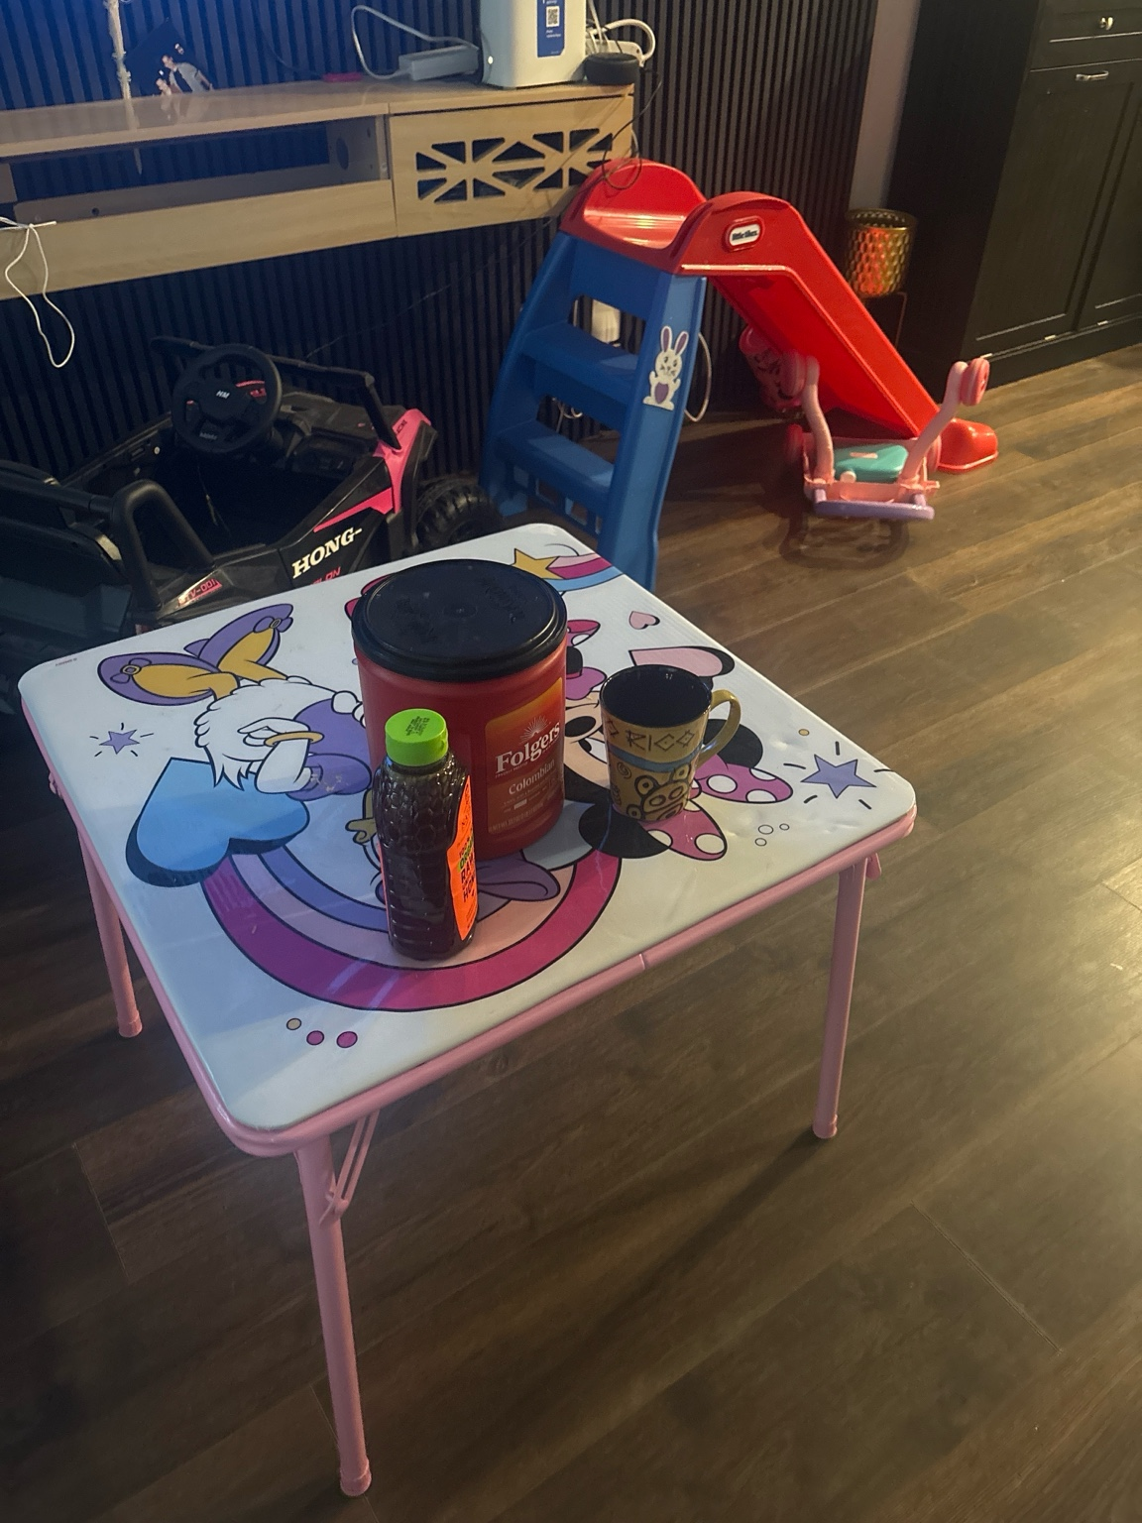
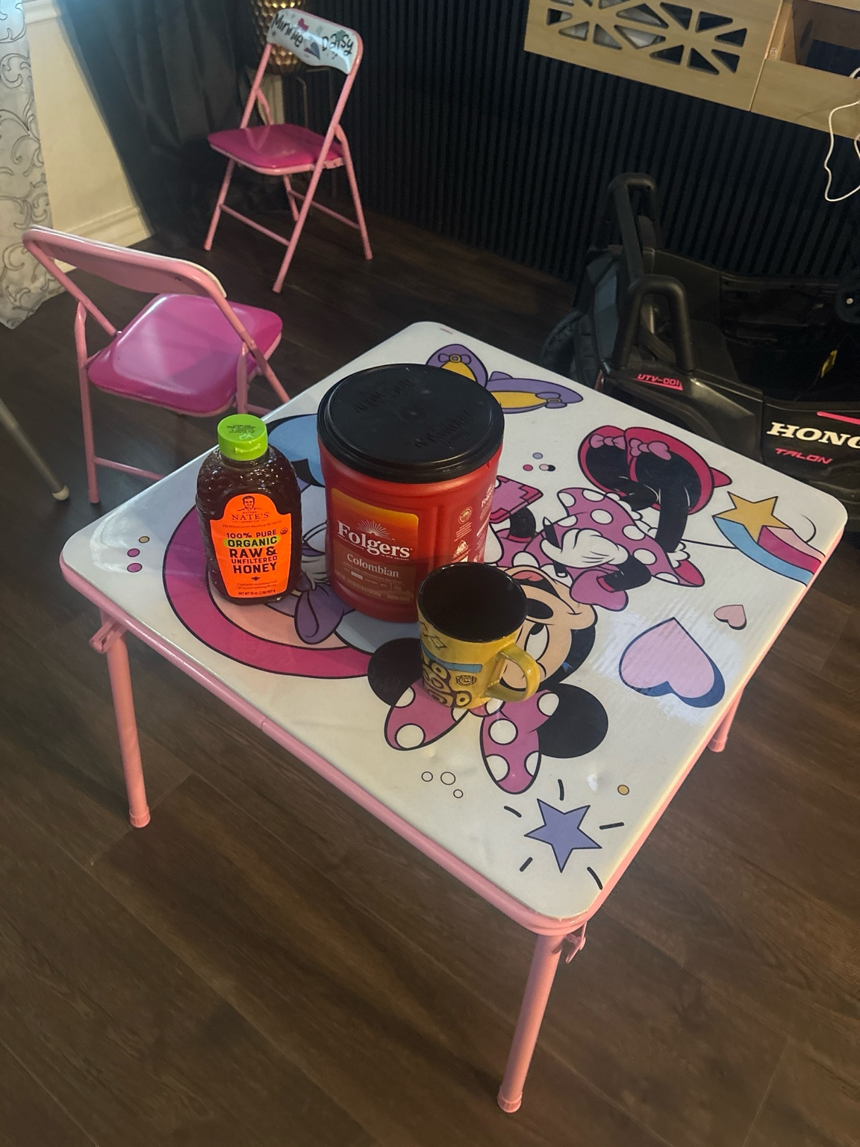
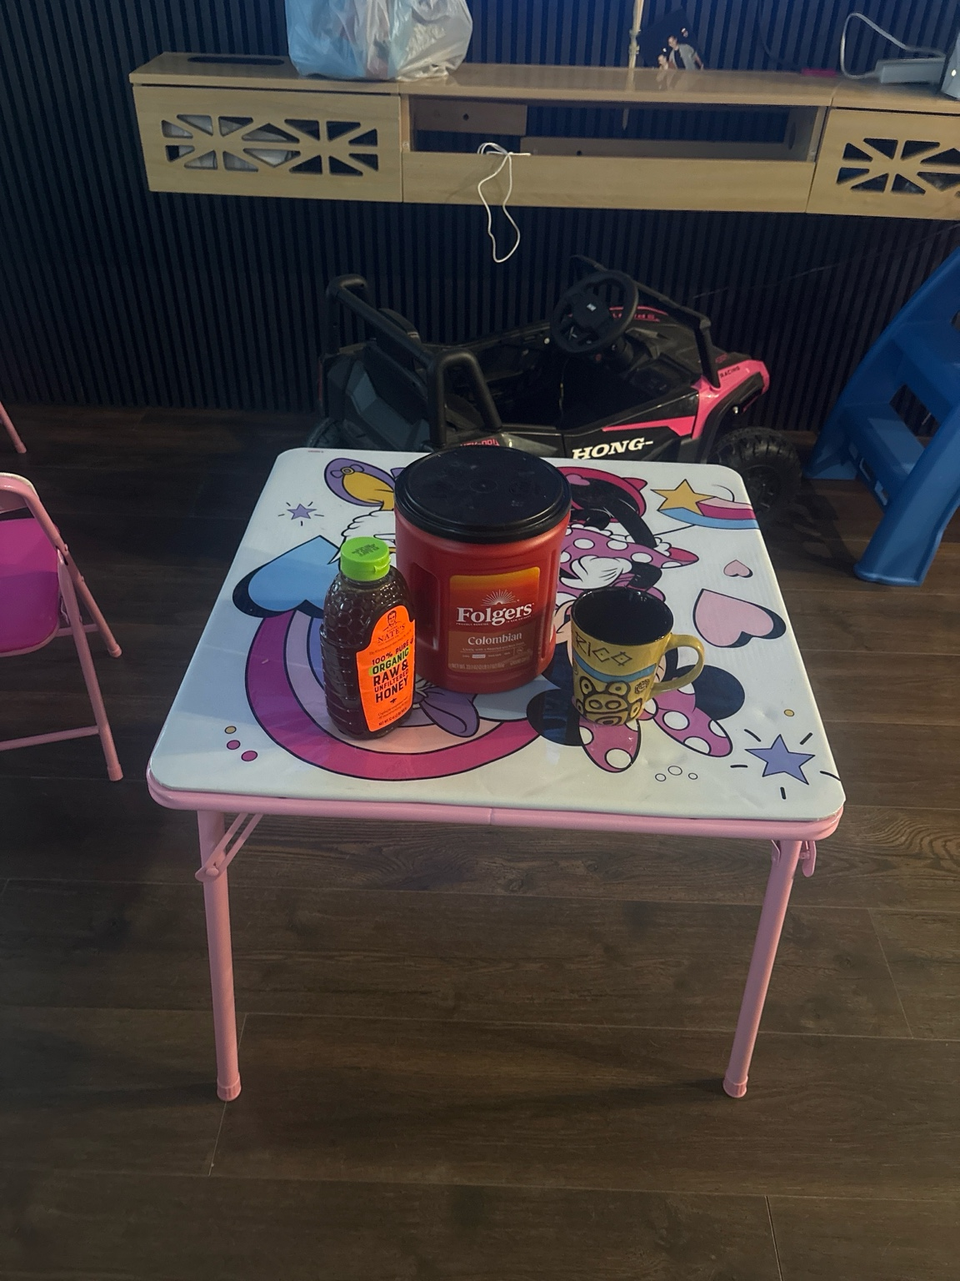

Objects to Be Replicated in 3D
The objects that will be replicated in the 3D scene include the table, the coffee container, the honey bottle, and the coffee mug. These items were selected because they are common household objects with clearly defined geometric forms. The table will serve as the base of the scene, while the remaining objects provide variation in height, scale, and shape.

Basic 3D Shapes Used
The table surface will be modeled using a plane to ground the scene. The table legs can be constructed using scaled cylinders. The coffee container will be created primarily from a cylinder with a smaller cylinder used for the lid. The honey bottle will also be modeled using a cylinder, with slight scaling adjustments to represent the tapered shape. The coffee mug will be composed of a cylinder for the cup body and a torus for the handle, making it an object constructed from multiple basic 3D shapes.

Scope and Feasibility
This scene was chosen because it balances simplicity with sufficient complexity to meet and exceed the project requirements. All objects can be constructed using basic OpenGL shapes, and the scene allows for clear demonstration of scaling, translation, and object composition. The use of multiple real-world reference images ensures accuracy while keeping the scope appropriate for Milestone One.

